## **PYTHON IDE INSTALLATION**

|  |  |
| --- | --- |
| **TEAM ID** | **PNT2022TMID24852** |
| **PROJECT TITLE** | **IoT BASED SMART CROP PROTECTION SYSTEM FOR AGRICULTURE** |
| **DATE** | **29 OCTOBER 2022** |

Python is a computer programming language often used to build websites and software, automate tasks, and conduct data analysis. Python is a general-purpose language, meaning it can be used to create a variety of different programs and isn't specialized for any specific problems.

**STEP 1:**

• Python is installed successfully

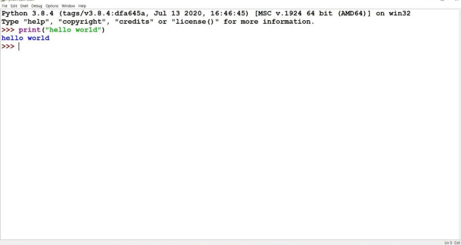

**STEP 2:**

• The required python libraries are installed.

• Watson IoT Python SDK to connect to IBM Watson IoT Platform using python code is installed

• pip install wiotp-sdK

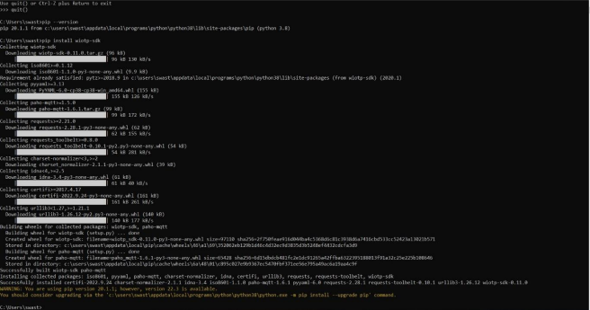

• Python client library for IBM Text to Speech is installed

• pip install --upgrade "ibm-watson>=5.0.0

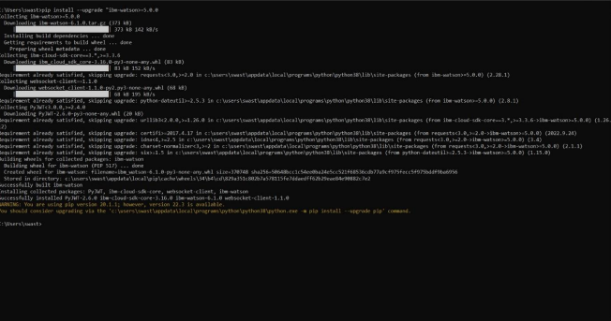

• Required libraries for Cloud object storage is installed.

• pip install ibm-cos-sdk

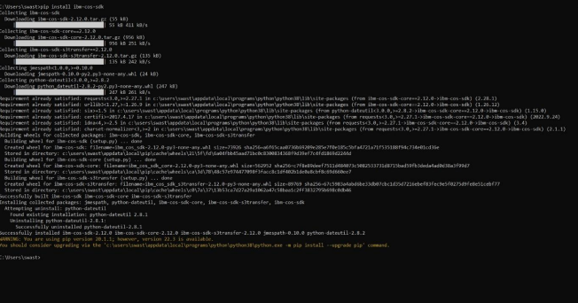

• pip install -U ibm-cos-sdk.

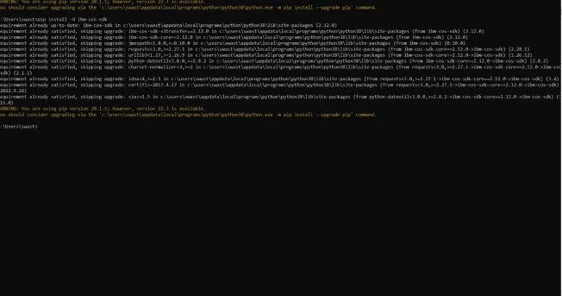

• pip install boto3

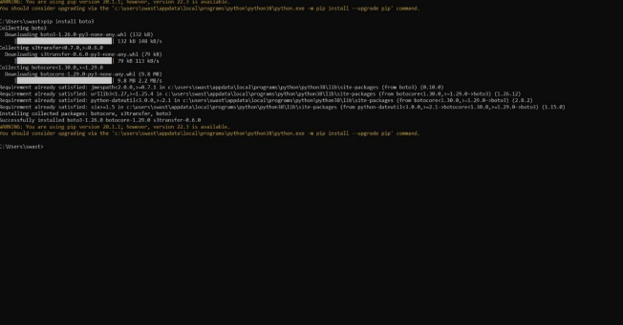

• pip install resources

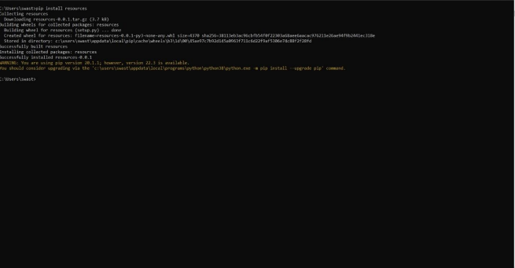

• pip install cloudant

